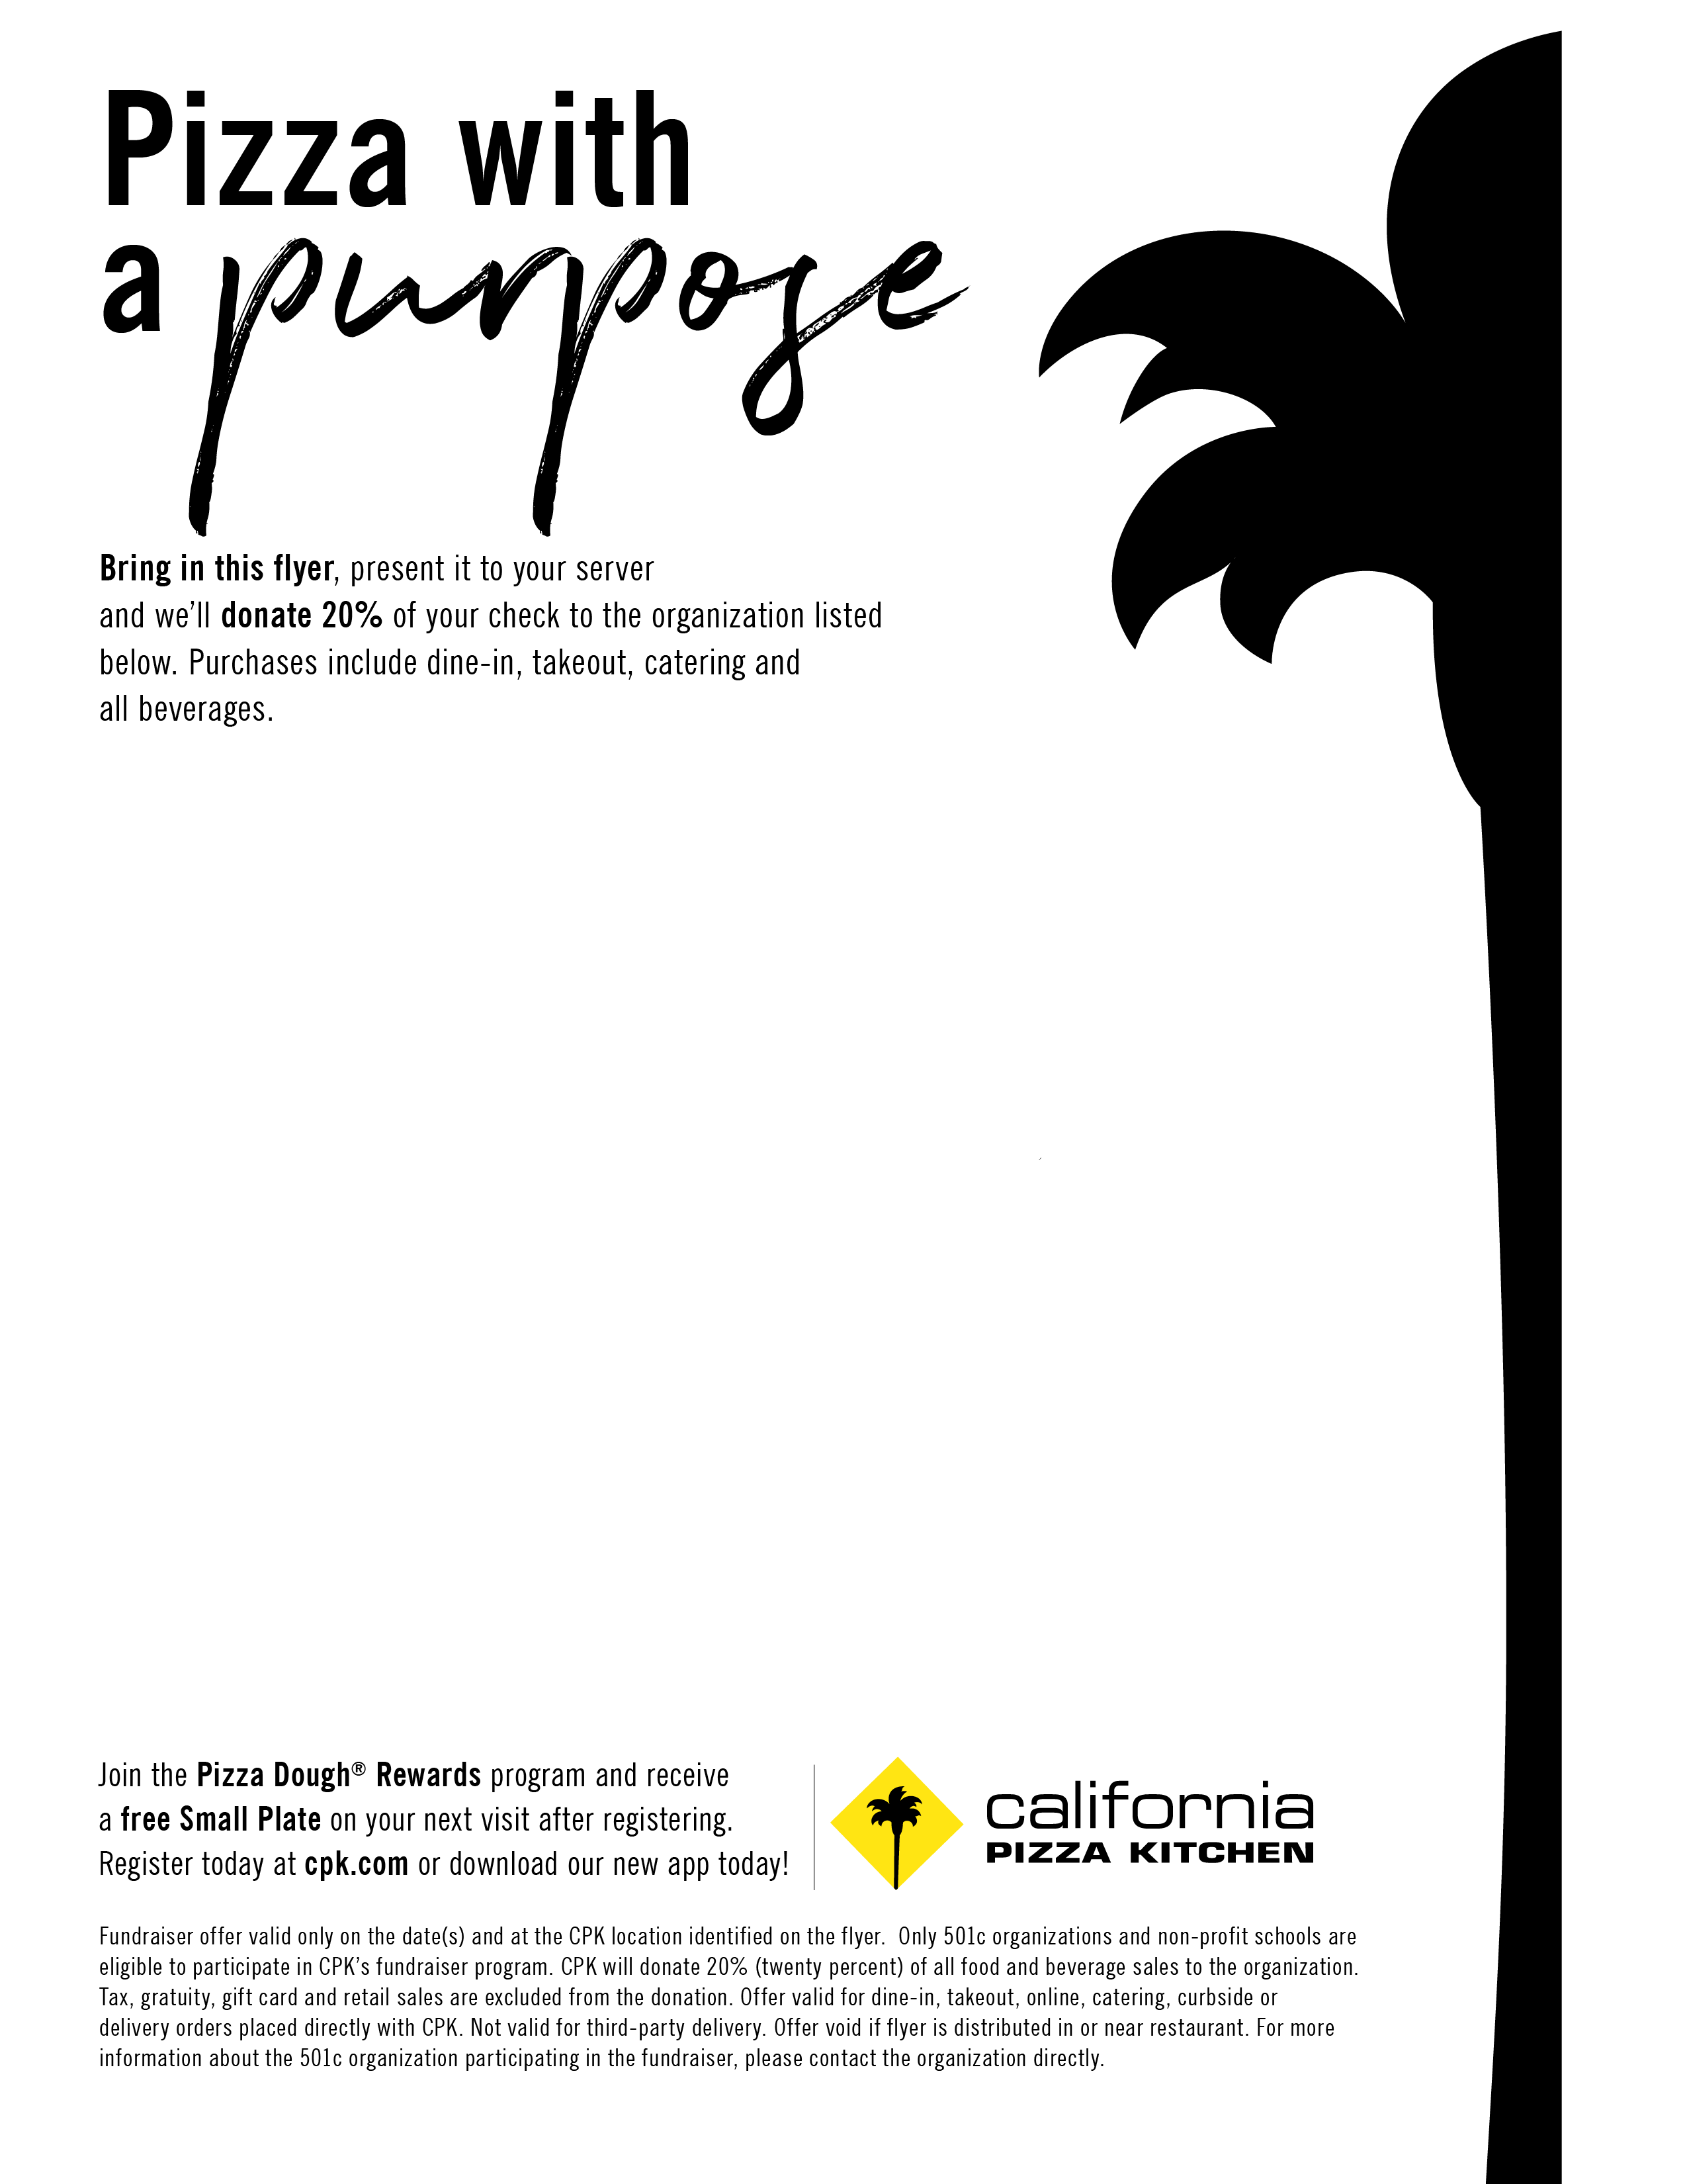

**Valid at the following location:  
California Pizza Kitchen**Linden Square-Wellesley

Natick Mall- Natick

Prudential Center-Boston

South Shore Plaza-Braintree

MarketStreet- Lynnfield

Foxwoods Casino

Westfarms Mall- West Hartford

**Fundraiser in support of:  
National Ovarian Cancer Coalition**Wednesday May 8th, 2019  
(All Day)